

MAWLANA BHASHANI SCIENCE AND TECHNOLOGY UNIVERSITY

Santosh,Tangail-1902

LAB REPORT

Lab Report No : 01

Lab Report name : Installing Linux operating system

Course Title : Operating System Lab

Course Code : ICT-3110

Date of Performance : 28/09/2020

Date of Submission :30/09/2020

Submitted by,

Student Name : Fatema Tuj Jannat

Student ID : IT-18028

Session : 2017-18

3rd Year 1st semester

Dept. of ICT

Submitted to,

Nazrul Islam

Assistant Professor

Dept. of ICT,

MBSTU.

# Name: Fatema Tuj Jannat

# ID:IT-18028

# Course: Operating System Lab

# Lab Report no: 01

# Lab Report 1: Installing Linux Operating System

# a)What’s Linux operating System

**Linux**® is an open source **operating system** (**OS**). An **operating system** is the software that directly manages a **system's** hardware and resources, like CPU, memory, and storage. The **OS** sits between applications and hardware and makes the connections between all of your software and the physical resources that do the work.

# b)Different types of Linux Operating System

1. LINUX MINT
2. MANJARO
3. DEBIAN
4. UBUNTU
5. SOLUS
6. FEDORA
7. ANTERGOS
8. ELEMETARY OS
9. OPENSUSE

# C)Installing Linux using USB stick

# Step:1

The Ubuntu desktop is easy to use, easy to install and includes everything you need to run your organisation, school, home or enterprise. It’s also open source, secure, accessible and free to download.

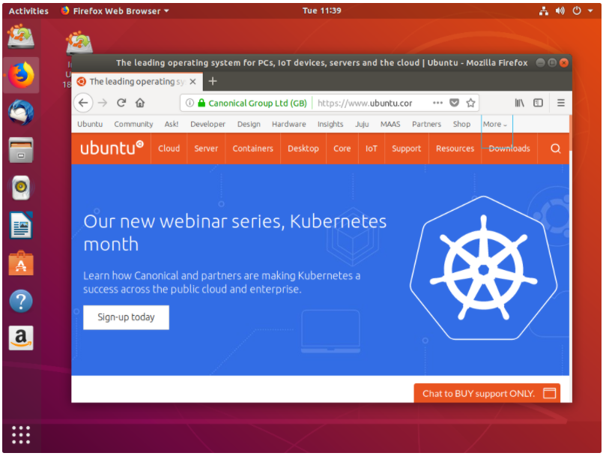

# Step:2

we’ll need to consider the following before starting the installation:

* Connect the laptop to a power source.
* Ensure we have at least 25 GB of free storage space, or 5 GB for a minimal installation.
* Have access to either a DVD or a USB flash drive containing the version of Ubuntu we want to install.
* Make sure we have a recent backup of our data.

# Step:3

It’s easy to install Ubuntu from a DVD. Here’s what we need to do:

1. Put the Ubuntu DVD into your optical/DVD drive.
2. Restart computer.

As soon as our computer boots we’ll see the welcome window.

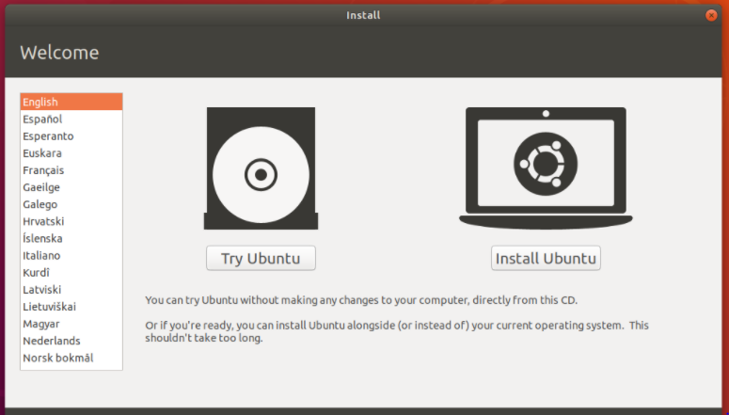

From here, we can select our language from a list on the left and choose between either installing Ubuntu directly, or trying the desktop first .Depending on our computer’s configuration, we may instead see an alternative boot menu showing a large language selection pane. User mouse or cursor keys to select a language and we’ll be presented with a simple menu.

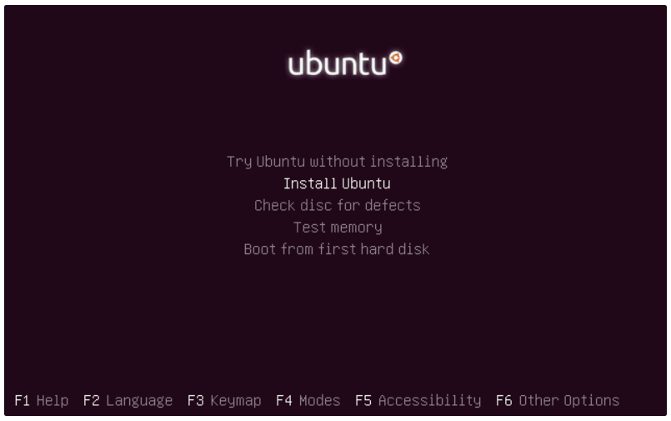

Select the second option, ‘Install Ubuntu’, and press return to launch the desktop installer automatically.

A few moments later, after the desktop has loaded, we’ll see the welcome window. From here,weu can select your language from a list on the left and choose between either installing Ubuntu directly, or trying the desktop first.

# Step:4

Most computers will boot from USB automatically. Simply insert the USB flash drive and either power on computer or restart it. we should see the same welcome window we saw in the previous ‘Install from DVD’ step, prompting to choose our language and either install or try the Ubuntu desktop.

# Step:5

You will first be asked to select your keyboard layout. If the installer doesn’t guess the default layout correctly, use the ‘Detect Keyboard Layout’ button to run through a brief configuration procedure.After selecting *Continue* we’ll be asked *What apps would you like to install to start with?* The two options are ‘Normal installation’ and ‘Minimal installation’. The first is the equivalent to the old default bundle of utilities, applications, games and media players — a great launchpad for any Linux installation. The second takes considerably less storage space and allows you to install only what you need.

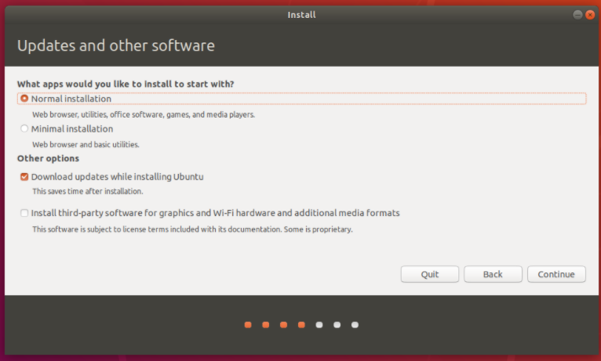

# Step:6

Use the checkboxes to choose whether you’d like to install Ubuntu alongside another operating system, delete your existing operating system and replace it with Ubuntu, or — if you’re an advanced user — choose the ’Something else’ option.

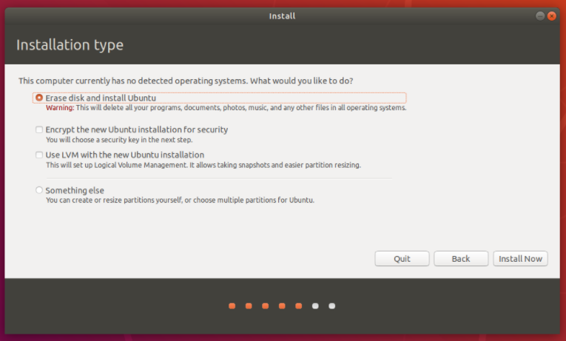

# Step:7

After configuring storage, click on the ‘Install Now’ button. A small pane will appear with an overview of the storage options you’ve chosen, with the chance to go back if the details are incorrect.Click Continue to fix those changes in place and start the installation process.

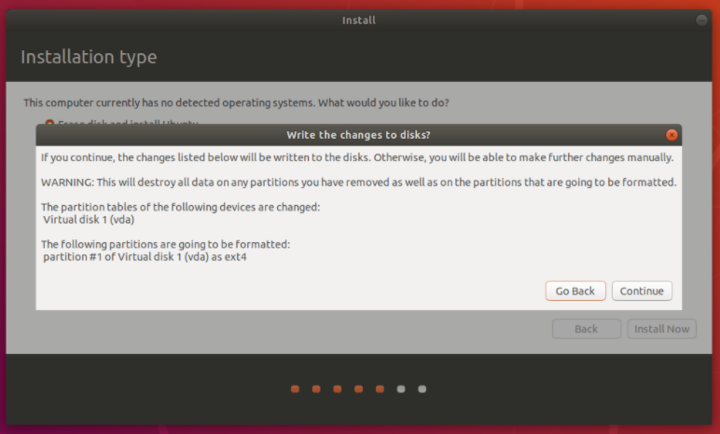

# Step:8

If you are connected to the internet, your location will be detected automatically. Check your location is correct and click ’Forward’ to proceed.

# Step:9

Enter your name and the installer will automatically suggest a computer name and username. These can easily be changed if you prefer. The computer name is how your computer will appear on the network, while your username will be your login and account name.

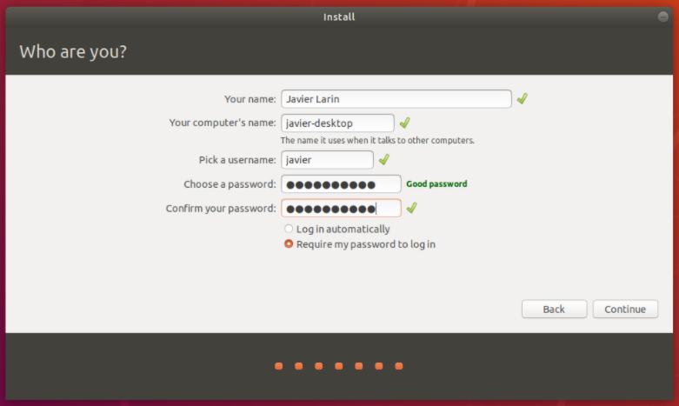

# Step:10

The installer will now complete in the background while the installation window teaches you a little about how awesome Ubuntu is. Depending on the speed of your machine and network connection, installation should only take a few minutes.

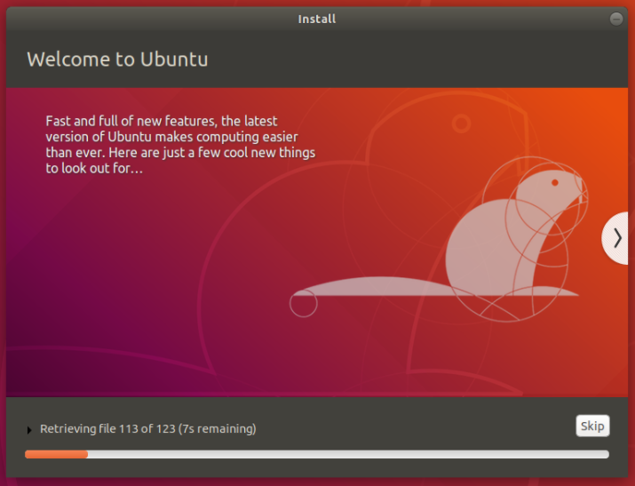

# Step:11

After everything has been installed and configured, a small window will appear asking you to restart your machine. Click on Restart Now and remove either the DVD or USB flash drive when prompted. If you initiated the installation while testing the desktop, you also get the option to continue testing.

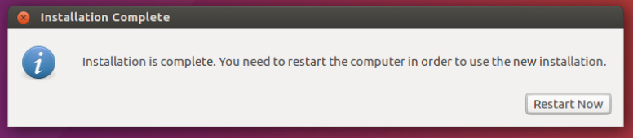

# Conclusion:

Installing linux is a quite long term process.The earlier steps should be done carefully.Because the 6th to 8th steps seemed a bit hard to me but could be recoverd.